**CS6461 Project Part 2**

Brian Prisbe, Charles Liu, Christian Guardado, Danacea Vo

**Java Version Required: JDK 16 or Higher to run the application**



How I ran on my computer using JDK-17:

1. Downloaded jdk-17

2. Command Prompt – went into jdk-17/bin

3. Ran “java -jar “absolute path to jar file””

If the default java version in your computer is JDK 16 or Higher, you can run our .jar file with double click.

**Basic Operations:**

1. IPL button starts computer

a. Initializes the memory (Reads from ipl.txt file)

b. Sets PC to 6 (We assume first instruction will be given at 6)

c. Waits for either run or single step (SS)

2. If SS clicked

a. Will run one instruction and GUI will be updated

b. Continue to click SS to execute a single instruction

3. If Run click

a. The entire program will be executed

4. When program finishes – Click IPL button to select other program

**Read IPL File**

We use file chooser to read from file outside. When clicked IPL button, the program will show a window to let user to choose files from computer. The choosing window is like below:

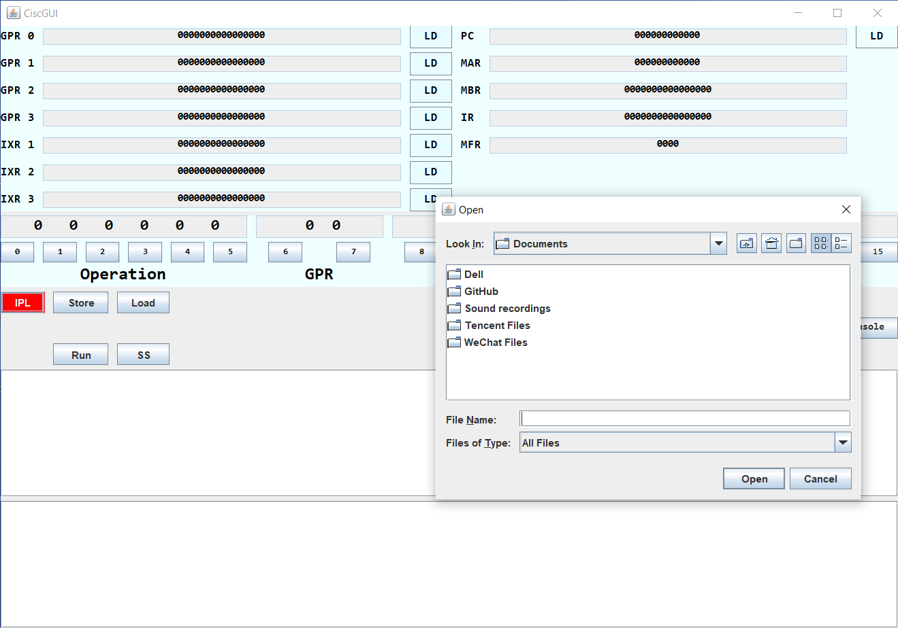

After choosing the txt file contenting initial program, click the open button, the program will read the file and do the initialization.

**Test Instructions**

Our simulator can only allow user to test load and store Instructions from the GUI.

Change the initial program in IPL.txt allows you to test other Instructions in the description

You can also change the content of registers while executing the program through the number buttons below and LD buttons followed by registers

**Attention**: there are Memory Reservation restriction in our program, as our simulator will start to execute the initial program at the 6 address in the memory, which means the first instruction of your initial program must be loaded to 0006.

**Run program 1**

1. Run the simulator

2. Click IPL button

3. Select program1.txt in the folder we submitted

4. Click **run button** to run program 1 or **ss button** to run 1 instruction every click

5. The program will pop out a window to ask user to do the input.

According the description, you will be asked to input numbers between 0 and 65535 for 21 times.

The last number will be the target number for our program to find the closest number in the first 20 numbers.

Input window is like below:

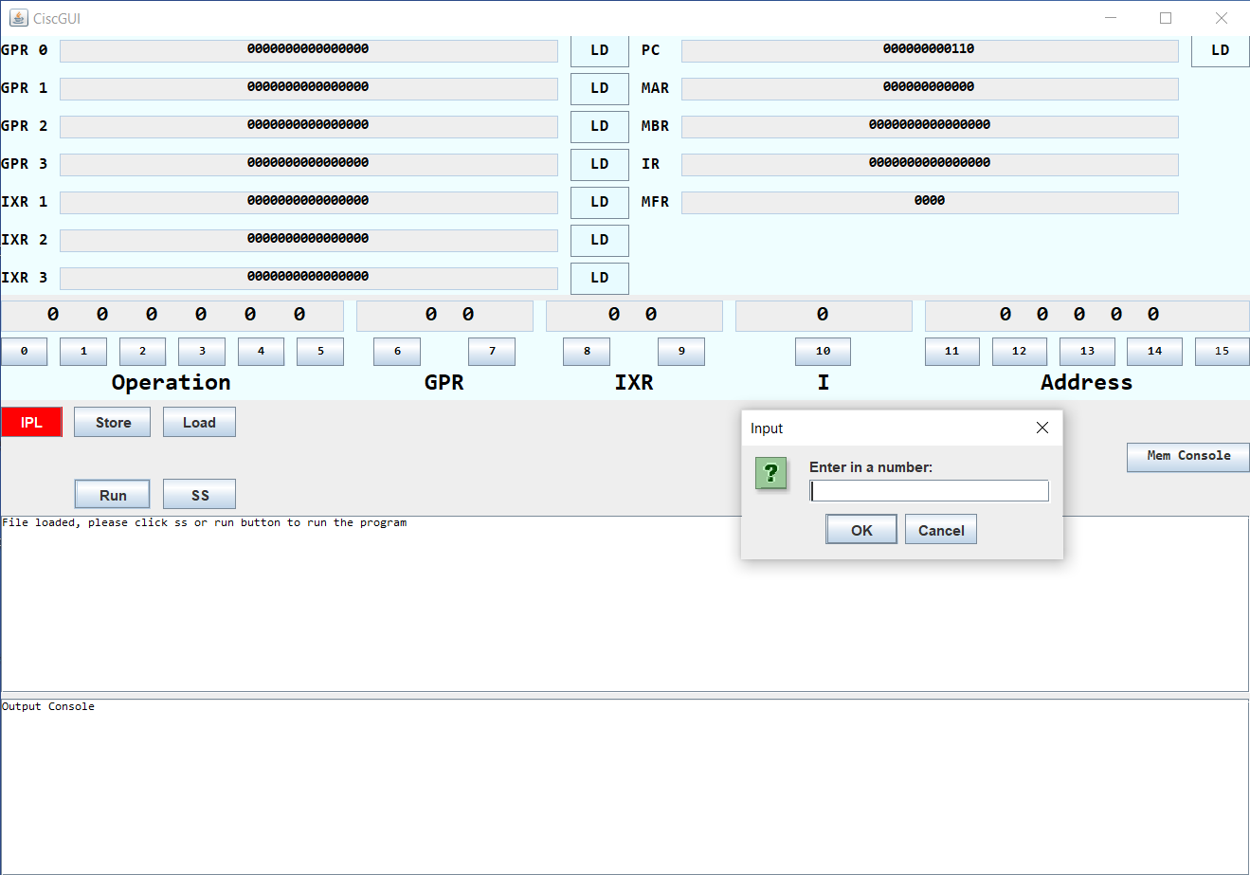

6. The program will print 22 numbers in the console, the last number is the result (the closest number to the target)

**Additional Functionality**

Create a binary value in GUI (Operation, GPR, IXR, I, Address)

This binary value can be loaded in any of the registers that have LD buttons

The binary value can also run Load and Store instructions

Assuming the correct Opcode is given for a load or store instruction

**Memory Console**

**Mem Console Button** - Prints all memory contents to console (you can )

Prints an error if incorrect instruction for Load and Store buttons

Prints when the program has finished

**Output Console**

Prints the data while executing OUT instruction